 | Organisation with which MoU is signed | Name of the institution/ industry/ corporate house
1 | Hans Raj Mahila Maha Vidyalaya Jalandhar,Punjab | BFSI Sector Skill Council of India | National webinar on Working of Export House in Apparel Sector under the initiative of Industry Academia Interface at HMV  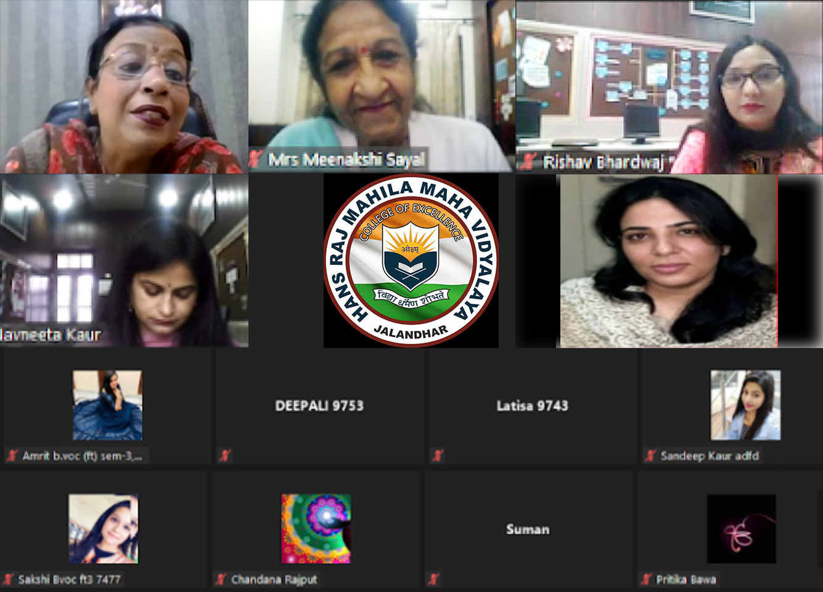  Hans Raj Mahila Maha Vidyalaya under the initiative of Industry Academia Interface started a one week web series under Community College. First day of the webinar was started with a webinar on the “Working of Export House in Apparel Sector” under the community college course of Fashion Designing, which is a one year course and can be extended up to two years Advance Diploma. Any female with +2 as basic qualification and any age group can join the course. The course is further certified by MHRD, Sector Skill council of India under certification of Apparel Sector which is acceptable worldwide. Ms. Nidhi Trehan, Ex. Additional Director Quality and Standards, Apparel Made up Home Furnishing, Sector Skill Council herself was the resource person to address the students and fashion fraternity. Working of Apparel Industry from beginning like Concept of Buying House, Export House, arrangement of fabric, production, storage of product, packaging, finishing, accessory arrangement and the procurement and maintenance of buffer stock and their distribution whenever and wherever necessary was discussed along with the working of Sector skill council. Terms like Levels, QP etc. were discussed in detail. The webinar was arranged with the motive of sharing the knowledge and experience on working of Export House in Apparel Sector to the faculty and students.
2 | Hans Raj Mahila Maha Vidyalaya Jalandhar,Punjab | Shri Vishwakarma Skill University | HMV organized National Web Conference on “New Education Policy: Perspectives and Challenges  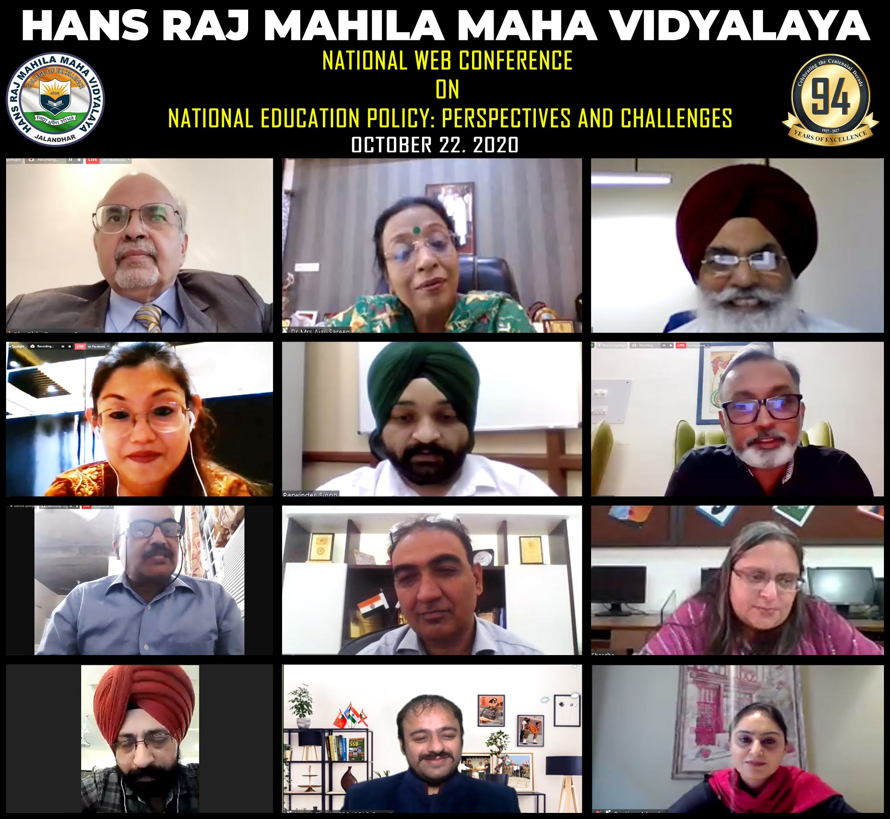  With the aim to empower India as a global knowledge superpower, the New Education policy provides new dimensions to the education system. To ponder on the nuances of the policy, Hans Raj Mahila Maha Vidyalaya organized a thought provoking National Web Conference on “National Education Policy: Perspectives and Challenges” under the dynamic guidance of Principal Prof. Dr. Mrs. Ajay Sareen. The one of its kind conference was organized on virtual platform under the aegis of Unnat Bharat Abhiyaan and coordinated by Dr. Ramnita Saini Sharda.  Opening on a pious note with the recital of Gayatri Mantra and DAV Anthem, the inaugural session on the topic “NEP: Perspectives and Challenges- A dialogue with the Stakeholders” was graced by renowned educationists, Sh. Shiv Raman Gaur, IAS (Retd.) Director Higher Education, DAVCMC, New Delhi and Dr. TS Benipal, Dean College Development Council, GNDU, Amritsar.  During the afternoon session, Lead speaker Dr. Randhir Rathore, Dean Academics, Shri Vishwakarma Skill University, said that By 2025, at least 50% of learners through the school and higher education system shall have exposure to vocational education. He said that secondary schools will also collaborate with ITI’s, polytechnics and local industry. Second speaker was Dr. Pangkhuri Borogohian, Anaylst, Apprenticeship Division, NSDC. She told about apprenticeship in detail and said that it is a combination of basic training and on the job training.
3 | Hans Raj Mahila Maha Vidyalaya Jalandhar,Punjab | S. Ajit Singh Foundation Society Jalandhar | HMV initiated a Start-Up Parwaaz – Nari Ki Udaan  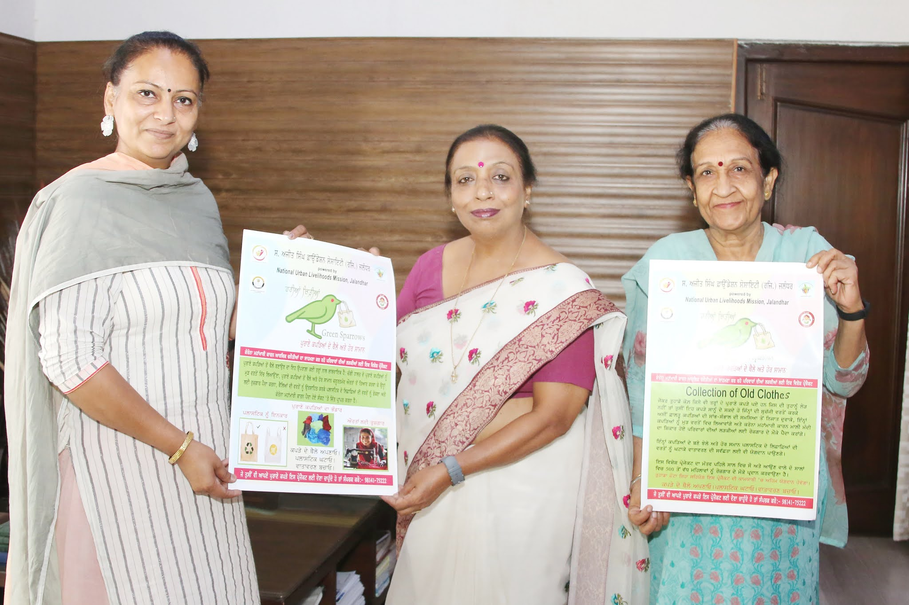  Holding always the vision of turning women into empowered women, the Community College of HMV initiated a start-up a named Parwaaz-Nari Ki Udaan under the dynamic guidance of Principal Prof. Dr. (Mrs.) Ajay Sareen. Under this initiative, the students of various skill based vocational courses of Community College will prepare and sell out their hand made goods which make them financially independent and skillfully refined. The students of Cooking and Catering Course will bake cakes, muffins, biscuits and will also prepare achaars, murabaas etc. All these items will be sold out at nominal rates. Students of Fashion Designing will prepare masks and also designer bags from old clothes which aware them about textile recycling and will sell them out and help the environment by avoiding the usage of plastic bags. Recently, the Community College has signed MOU with an NGO named S. Ajit Singh Foundation Society (Regd.), Jalandhar in order to initiate many novel projects to make the women to lead dignified life. Principal Dr. Ajay Sareen apprised that the initiatives like Parwaaz is meant to provide Vocational training to all sections of women so that employment can be generated and it will eventually create women empowerment. She added that many families of society are affected severely due to COVID pandemic and these kinds of projects help the women to be financially independent. Ms. Ramanpreet, President of NGO is running the project under the banner of Green Sparrow in which she provides wings to the women as financially independent. She arranges the vocational training for slum dwellers women and also manages employment opportunities for under privileged section.
4 | Hans Raj Mahila Maha Vidyalaya Jalandhar,Punjab | ITF International Trainers Federartion
5 | Hans Raj Mahila Maha Vidyalaya Jalandhar,Punjab | Advocate Vikrant Rna (Director Legal ,Punjab International Human Rights Organisation) | MOU signed between HMV and Advocate Vikrant Rana, Director Legal Punjab, International Human Rights  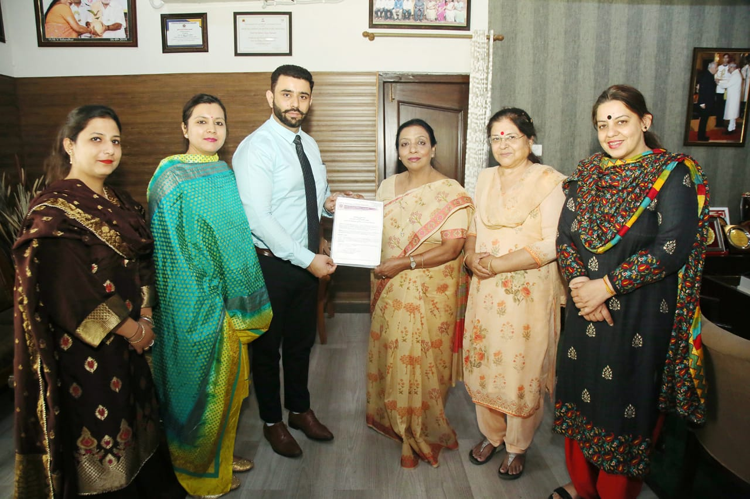  Hans Raj Mahila Maha Vidyalaya has signed a Memorandum of Understanding (MOU) with Advocate Vikrant Rana Director Legal Punjab, International Human Rights( Affiliated School to UNO and International Bar Association) in which training and leadership skills to the students of HMV will be provided by the Advocate Vikrant Rana and his team. With this collaboration, various activities, conferences and seminars shall be organized for the students. Further both the signatories will collaboratively work together for promotion of research and safeguard of the human rights in society.  The MOU was signed by Advocate Vikrant Rana and Dr. Ajay Sareen, Principal , Hans Raj Mahila Maha Vidyalaya. On this occasion Dr. Kanwaldeep Kaur, Dean Academics, Dr. Anjana Bhatia, Dean Innovations and Research, Ms. Maninder Kaur , Joint Secretary of IHRO and others were also present  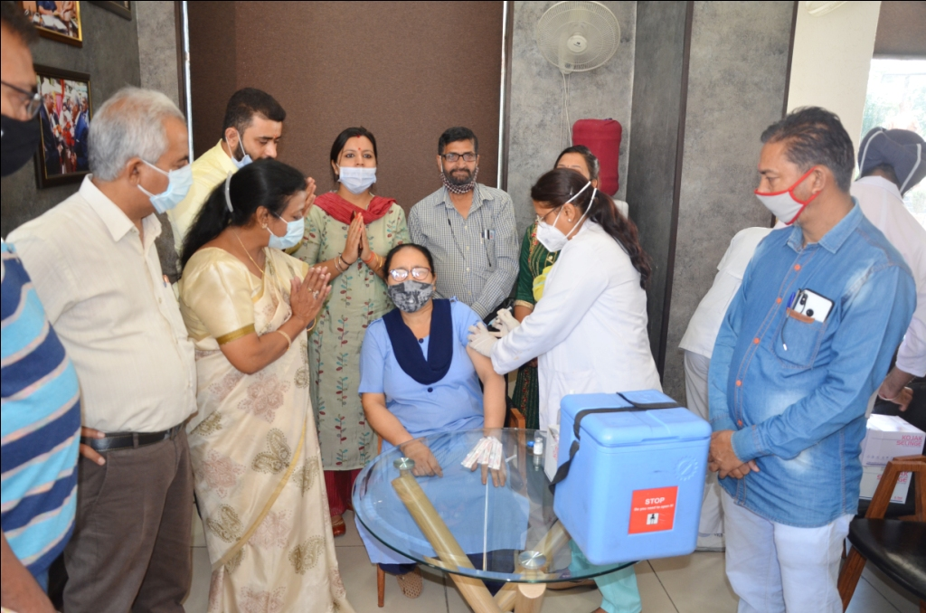  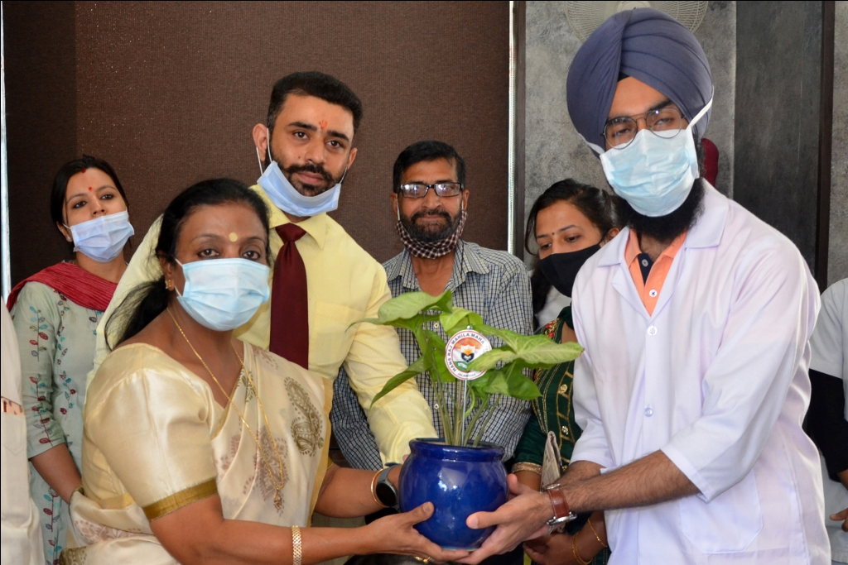  Hans Raj Mahila Maha Vidyalaya celebrated Birth Anniversary of Mahatma Hans Raj with all protocols and social distancing. On this occasion with a special permission of Local Administration, in collaboration with International Human Rights organization, a Special Vaccination Camp (COVID-19) was also organized.
6 | Hans Raj Mahila Maha Vidyalaya Jalandhar,Punjab | Ex Service Men Welfare Association Bhogpur Jalandhar | HMV signed MOU with Ex-Servicemen Welfare Association (Regd.) Bhogpur Principal Dr. Sareen honored for her welfare activitie  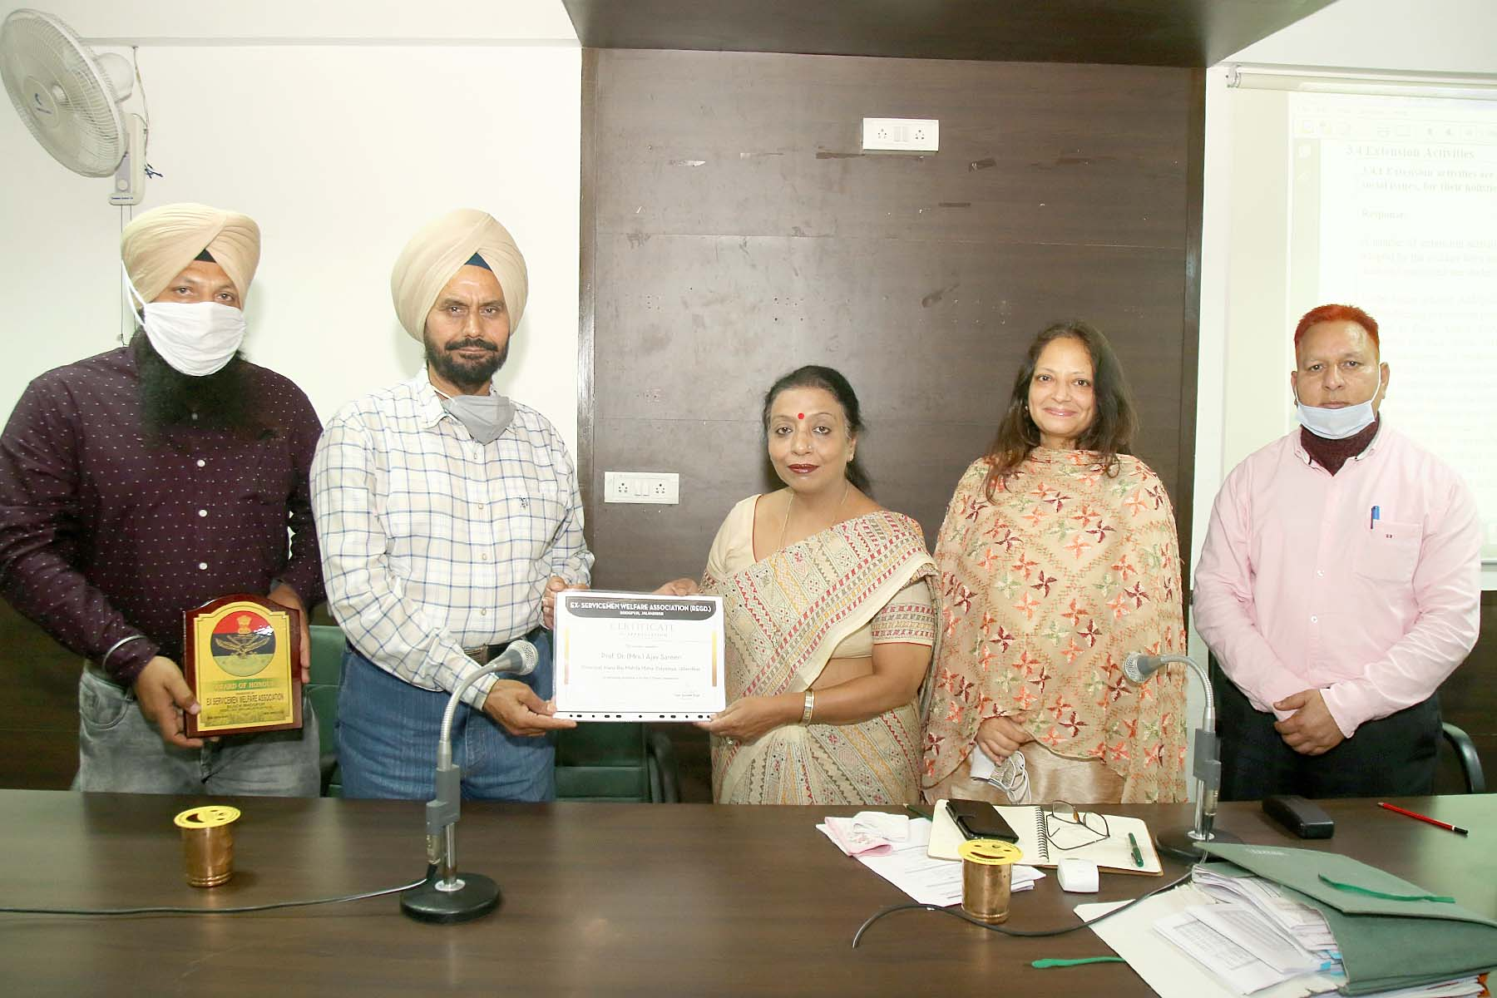  Hans Raj Mahila Maha Vidyalaya, Jalandhar and Ex-Servicemen Welfare Association (Regd.) Bhogpur, Jalandhar have entered into memorandum of understanding (MOU). The MOU describes the broad outlines of agreement between both parties to send experts and Resource Persons for guest lectures, personality development programmes, motivational lectures etc. The MOU also expresses that PG Department of Economics of Hans Raj Mahila Maha Vidyalaya, Jalandhar will help in data collection by conducting surveys and data analysis on socio-economic issues. This MOU will certainly benefit the students by providing opportunity of practical exposure of field surveys to students and analyzing real world socio-economic problems. The association also honoured Principal Prof. Dr. (Mrs.) Ajay Sareen for the welfare activities done by her especially for girls of the villages. Dr. Ajay Sareen and Head PG department of Economics Ms. Shallu Batra thanked the association for showing faith in the college. They said that the college will do more welfare activities in the near future in association with Ex-Service Men.
7 | Hans Raj Mahila Maha Vidyalaya Jalandhar,Punjab | Lakehead University (Ontario Canada)
8 | Hans Raj Mahila Maha Vidyalaya Jalandhar,Punjab | Skill Development Initiatives in Mnagement Sector
9 | Hans Raj Mahila Maha Vidyalaya Jalandhar,Punjab | NGO APAAR | International Webinar on “Gender Equity Issues in Pandemic Times” at HMV  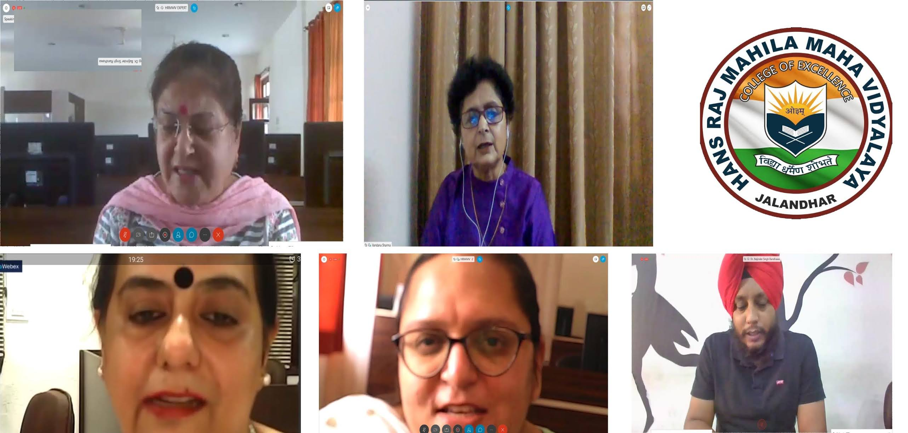  The department of Psychology and Sociology of Hans Raj Mahila Maha Vidyalaya organized an International Webinar on Gender Equity Issues in Pandemic times in collaboration with NGO APAAR under the aegis of IQAC as per the directions of Principal Prof. Dr. (Mrs.) Ajay Sareen. Webinar series coordinator Dr. Ramnita Saini Sharda stressed upon the need and significance of holding the webinar on this theme in the pandemic times. Dr. Baljinder Singh, HOD, Sociology, coordinator of the webinar introduced the topic of the webinar. Dr. Ashmeen Kaur, HOD Psychology, introduced the speakers of the webinar and moderated the sessions. The key speaker of the webinar was Dr. Vandna Sharma, Former Dean Social Sciences and HOD, Psychology, Punjabi University, Patiala, Professor of Eminence, Akal University, Talwandi Sabo. Through a very structured presentation, starting from vedic times to pandemic times, she raised issues pertaining to gender equity especially in context to Indian set up. The questions raised by the participants were answered very well.  The second speaker was Dr. Navneet Bhullar, Physician from U.S and founder of NGO APAAR (Altering Perceptions of Autism and assisting in rehabilitation). She discussed the issues of women at Global level and in specific context to people with intellectual disabilities. Both the speakers emphasized on the need for gender equity citing present statistics and suggesting models for reaching towards gender equality. Principal Prof. Dr. Ajay Sareen congratulated both the departments for successfully organizing the webinar. Dr Ashmeen Kaur gave a formal vote of thanks to the speakers, IQAC Coordinator Dr. Kanwaldeep Kaur, Webinar series Coordinator Dr. Ramnita Saini Sharda and the technical team.

